**Project Report**

Submitted in partial fulfilment of the requirements for the award of degree of

**BTECH (CSE)**

**Submitted To**

**LOVELY PROFESSIONAL UNIVERSITY PHAGWARA PUNJAB**



**From 15/June/2024 to 17/JULY/2024**

Submitted By:

**AKASH KUMAR MALIK**

Registration Number: **12323008**

#### Student Declaration

**To whom so ever it may concern**

**I, AKASH KUMAR MALIK, 12323008 hereby declare that the work done by me.**

On “Content Formulation, Video Making, Data and Report Making Of Social Event”

From 15/June/2024 to 17/July/2024, is record of original work for the partial fulfilment of the requirements for the awards of degree.

Date of Submission: 30/08/2024

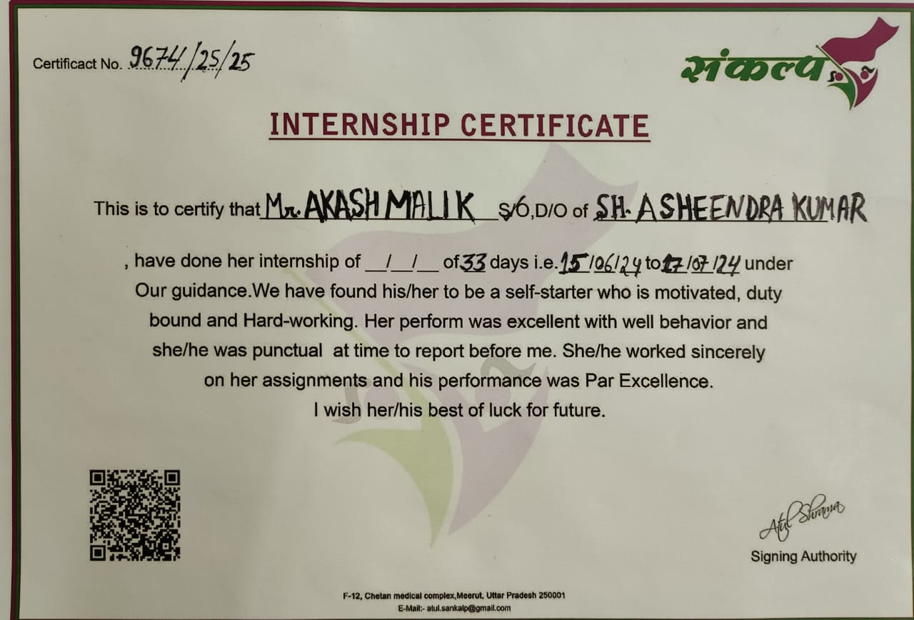***CERTIFICATE***

***NGO ID***

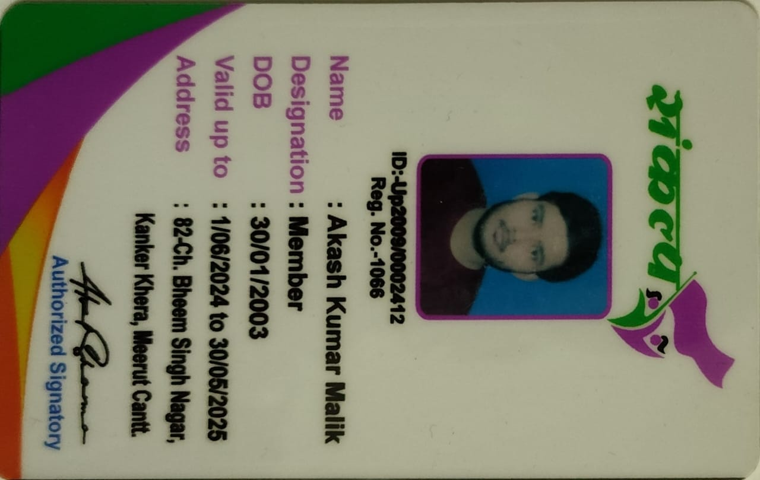

#### ACKNOWLEDGEMENT

I cannot express enough thanks to my committee for their continued support and encouragement. I offer my sincere appreciation for the learning opportunities provided by my committee.

My completion of this certification course could not have been accomplished without the support of my friend that I made in NGO most of them were from LPU itself so it was very easy for me to adjust with them and we together carry out several field visits .

Thank you for allowing me to take part to experience something from you to research and write.

Thanks to my parent and all my close friends who I did it complete by all the precious means. The timeless count that you gave to do it possible will not be

forgotten. Ultimately, to my loving, caring and all the supportive friends and classmates who resourcefully supported me.

My Deepest gratitude and love to all the ones who gave the countless time with the kind attention. It was a great comfort

and relief to know that what you were willing to provide while I completed my work. My warm-hearted thanks to all the ones.

### Introduction of our NGO’s:

1st **SANKALP** (Let me Speak)

A non-governmental organization (NGO) is a non-profit group that functions independently of any government NGOs, sometimes called civil societies, are organized on community, national and international levels to serve a social or political goal such as humanitarian causes or the environment.

Running from 1997 , currently working in the 13 districts with 3000 members.

**Sankalp is a committee of men and women and students who** come from all walks of life with the motto of being the change they want to see in the society in terms of societal upliftment of poor and all. The biggest problem our country faces is the presence of too many people discussing issues but few trying to find solutions. Where we understand that finding loopholes are important, we believe every small action gets counted and it is important that we give away the complaints and try to do things for a brighter tomorrow.

If we want our democracy to work, it becomes extremely important that civil society is responsible and actively involved because when we get to choose the

government, we become a part of it and as has been rightly said, with great power comes great responsibilities.

**Our committee has moto to help every person and society**. Work for only society development. Many NGOs unlike us only do the activities Like food distribution, copies pencil pen or study material distribution for children but we here in ***Sankalp*** do more than that, for society development and encouragement of youth we provide consultation to them we reach out for the poor to make them aware about the importance of education and hygiene we urge them to send their children in nearest government school on our expenses.

NGO activities include, but are not limited to, environmental, social, advocacy and human rights works. They can work to promote social or political change on a

broad scale or very locally. NGO play a critical part in developing society, improving communities, and promoting citizen participation.

***Sankalp*** is a group of women, men, young children, and students and is a nongovernmental organization but funded by various government resources.

They currently have their head office in Uttar Pradesh Meerut and they have a team of local leaders and other member who are working day and night to achieve aim one day.

**DEFINITION:**

A non-governmental organization (NGO) is a group of people from different countries acting together, but not connected with the government of any country. Usually non-governmental organizations are nonprofit - that is, they are trying to do something other than make money for the people who run them.

**AIM AND OBJECTIVES:**

Aims and Objectives of our Society are:

* To provide Food, Educational and Economic Empowerment to Women and Children.
* To safeguard the rights of the Child and provide for the well-being of Children in need, more particularly.

1. Children exposed to any form of abuse.
2. Children deprived of education .
3. Children suffering from ill health, physical and mental.

* To identify the beggars and impress upon them the significance of dignified living and persuade them to take up an alternative livelihood and to take such measures so as to equip them in attaining such means of living.
* To provide medical and legal aid and assistance to the old aged and to take such other Measure to ensure their social wellbeing.

•To help each and every needy.



OBJECTIVE OF OUR NGO :-

*The objective of the true NGO, the non-governmental Organisations should be the social as well as economic welfare. The objective of the NGO should be to provide education to the children so that their society should develop with modern thinking and also help the economy of the country with good GDP. Trust is the great NGO of India who objects at providing Food,educational facilities to all. They mainly work to bring the rural and the urban people together for a better society. In Collaboration with Club 60 of meerut They helps the rural people by providing them free education. The Joint trust for child sponsoring organisation who have helped many poor*

##### Scope of the our SANKALP

The scope of an NGO that provides free food for people and children encompasses a range of significant objectives and impacts. Primarily, the NGO aims to address food insecurity and malnutrition by ensuring access to nutritious meals. This initiative contributes to improved health and well-being among the beneficiaries.

Furthermore, the NGO's scope extends to fostering community engagement and social cohesion. By creating spaces where people can gather to receive meals, it promotes interaction and support among community members. This can lead to the development of a sense of belonging and shared responsibility.

Additionally, the NGO's activities can serve as a platform for advocacy and raising awareness about food- related challenges. By shedding light on issues like food waste, unequal distribution, and the importance of nutritional support, the NGO can potentially influence policy changes and drive a broader societal

impact.

Overall, the scope of an NGO providing social security for people and children is multi-faceted, encompassing short-term relief, community development, education, advocacy, and potential long-term transformation.

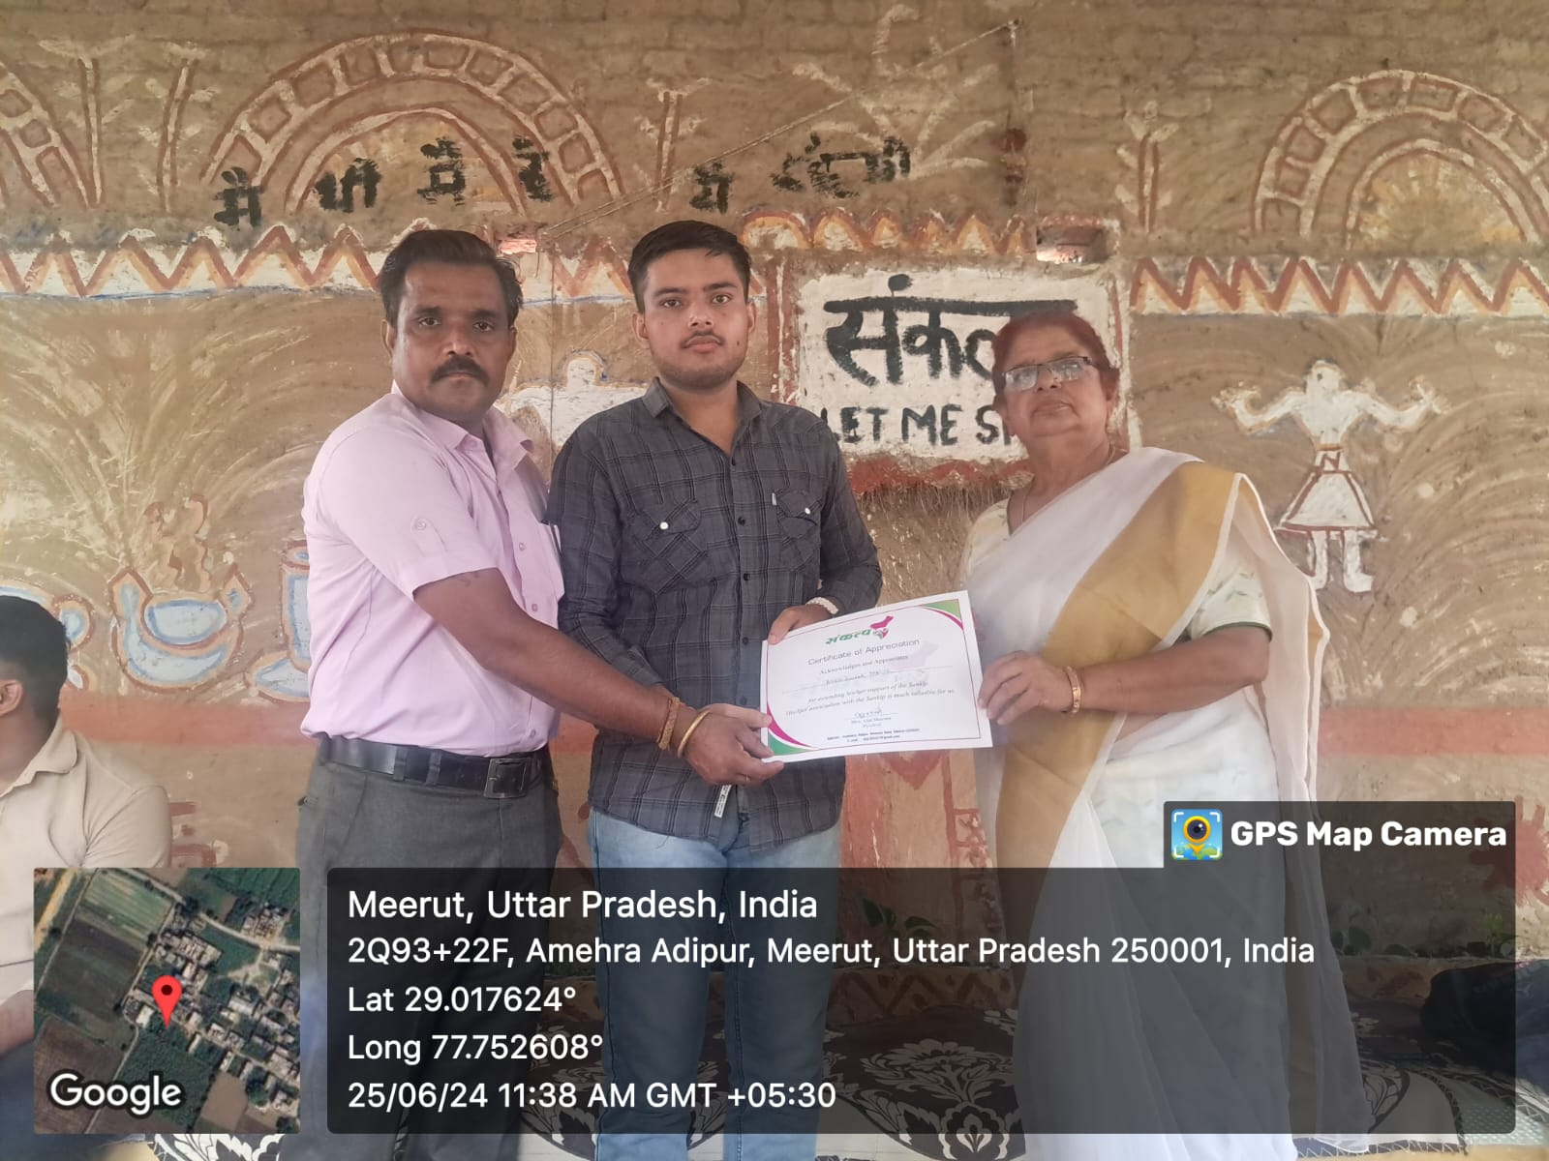

***Sankalp*** for poor class people.



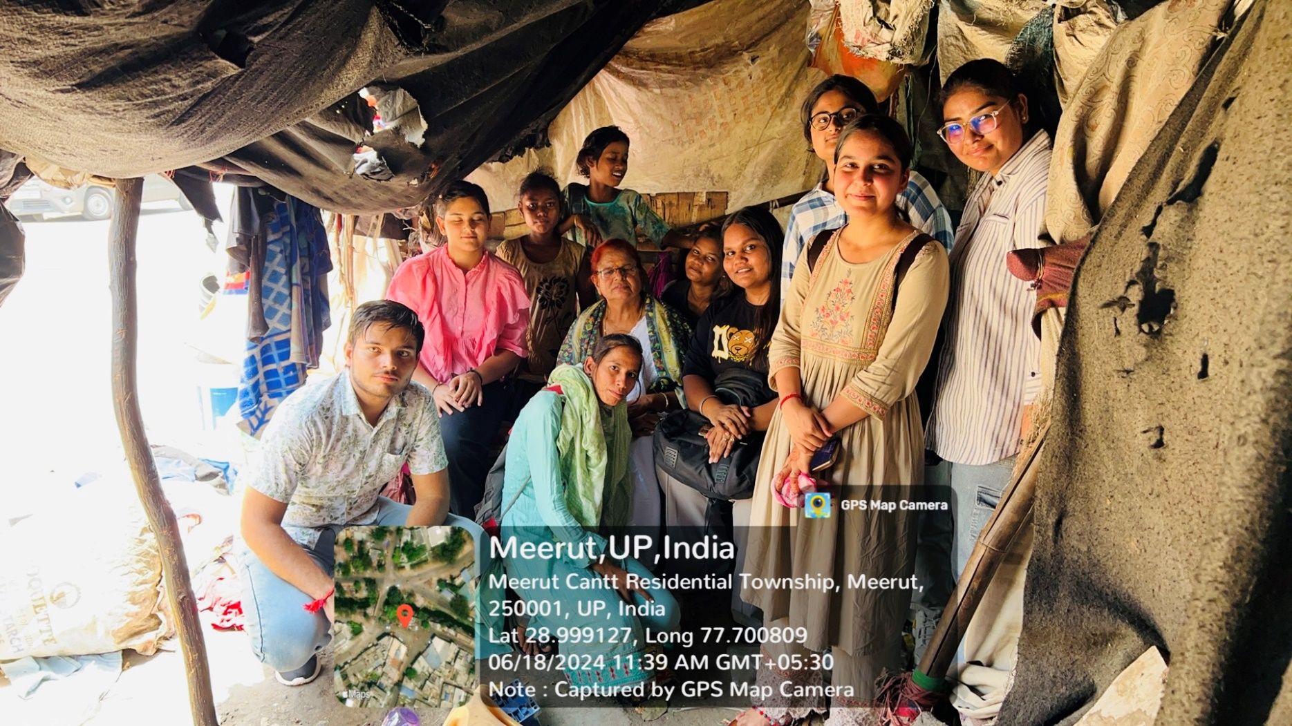

MISSION STATEMENT:

1. Education Advocacy & Spreading Awareness

* To promote education, especially education for girl child and women.
* To feed hungry peoples.

. • To promote use of Information & Communication Technology (ICT) for socioeconomic development of the community.

##### Spreading awareness regarding educating poor children.

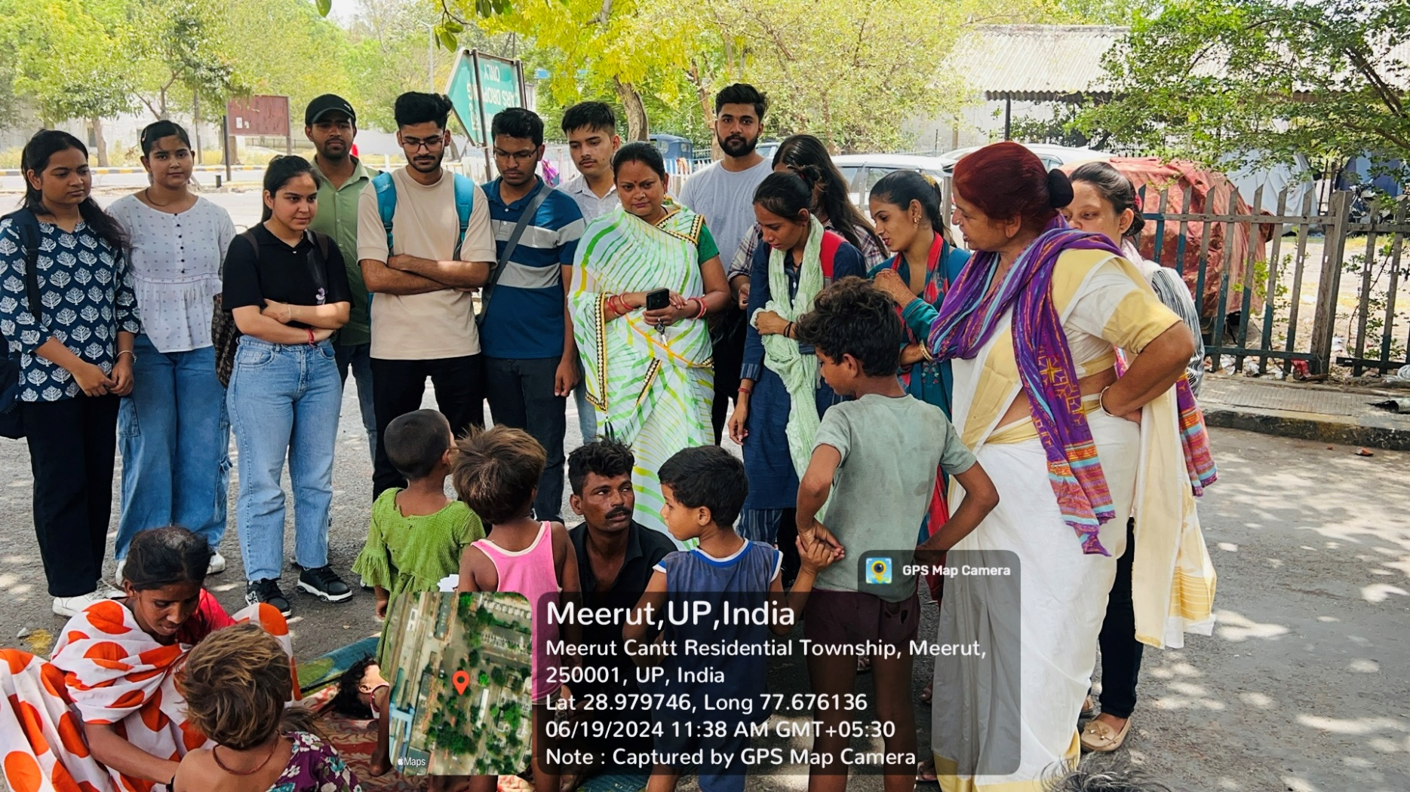



***Donating stationary and Providing Educational Advocacy and spreading awareness to children***

In Meerut Cantt, with this grassroots effort exemplifies how small actions can create lasting change. By donating stationery, advocating for education, and spreading awareness, compassionate members of Sankalp are sowing seeds of progress—one child at a time.

Remember, education isn’t just about textbooks; it’s about nurturing curious minds and empowering future leaders. 🌟

***Date: June 19, 2024* *Location: Meerut Cantt Residential Township, India***

Today we went to Meerut city Railway station where we met with many poor and homeless

children and people for them that railway station is their home as they somehow get food to eat

and water to drink at railway station. There we talked to a lot of these people tried to understand their concerns and worries about food security and family planning. We also spread awareness among them and their kids that how easy is it to get admission in a government school with the

help of our Sankalp NGO. We tried to make them understood that how education can reform their kids future and their family future also how they can uplift themselves in the social ladder without the help of anybody just by taking the advantage of schemes that government runs for BPL families.

We also get know that Some of These poor and homeless people somehow get into bad habits and

got addicted to alcohol and drugs like ganja and cannabis(bhang in common language ) then

we talked them and told them that how dangerous these things are for health.

Then we told them how it is important to have education and to make their child enrolled

in the government school through social welfare schemes runs by both state and central government. We Spread awareness among their children that it is necessary to have education and how education can change their life and how they can also give a better life to their parents.

***Date: June 19, 2024* *Location: Meerut Cantt Railway Police Station near Residential Township, India***

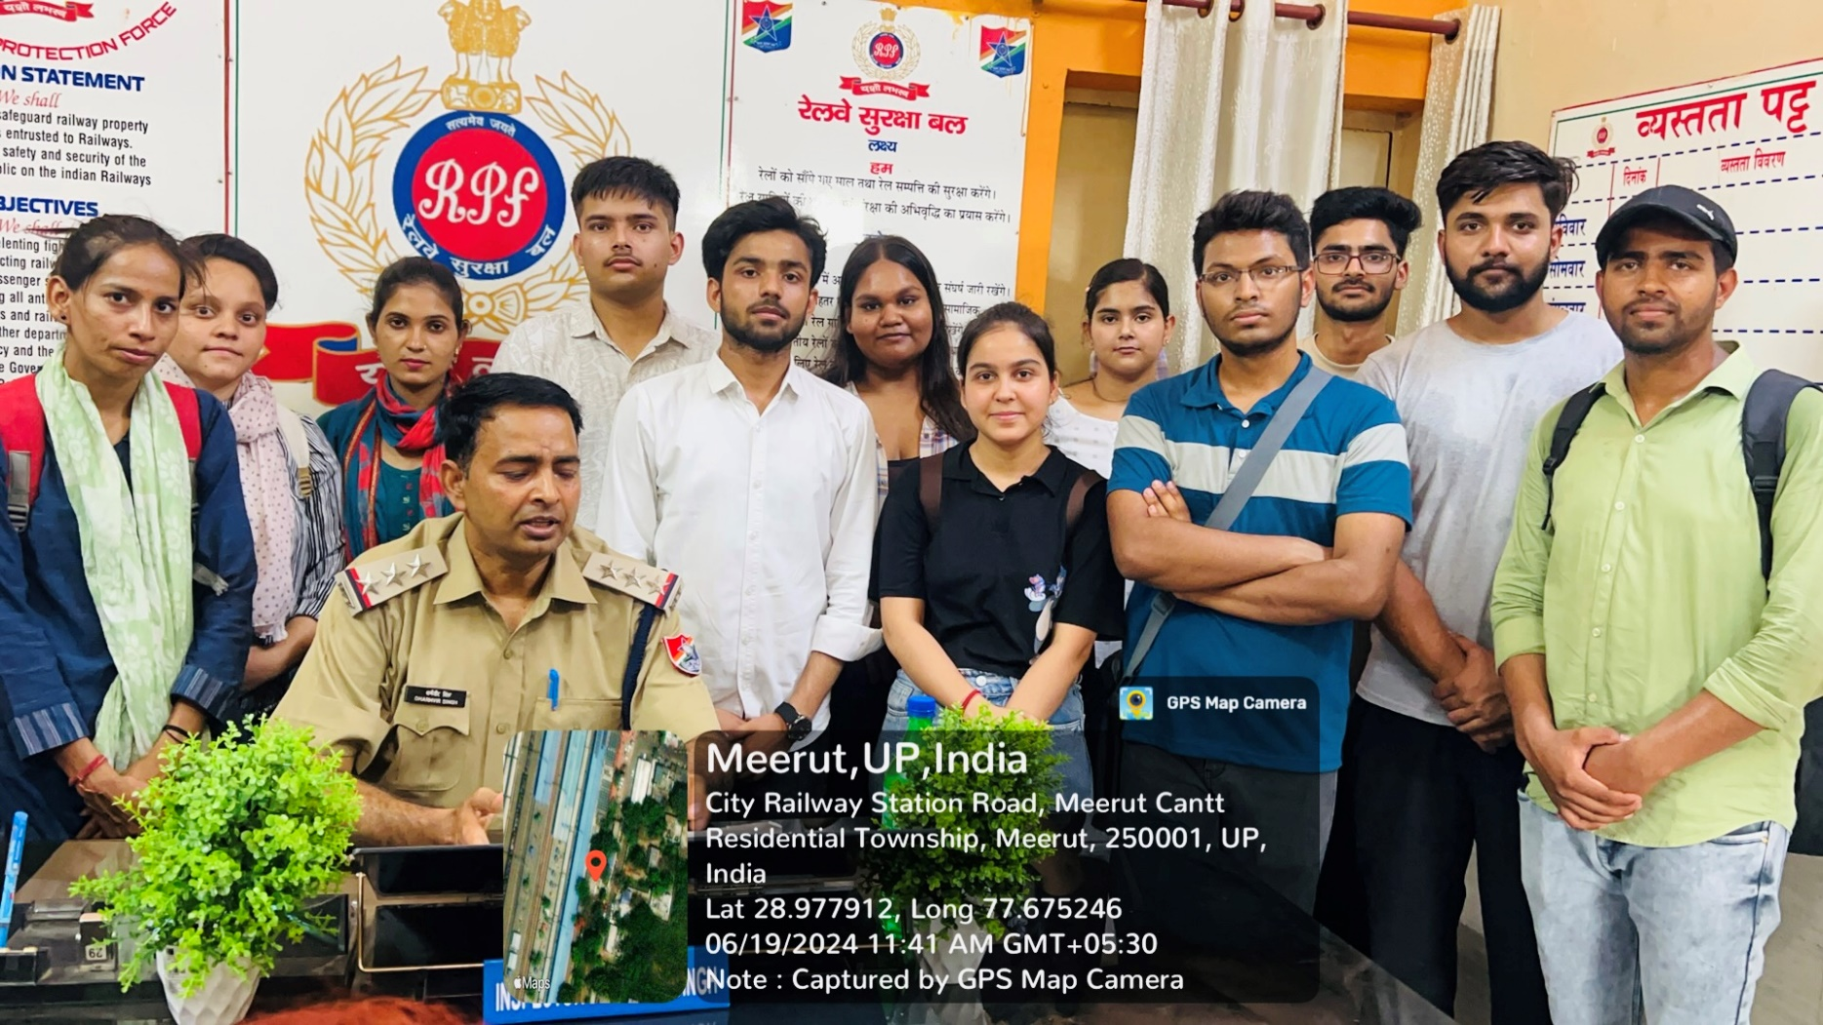



In the shadowy underbelly of society, a sinister trade thrives—one that preys on vulnerable individuals, exploits their desperation, and commodifies their very existence. Human trafficking, a global menace, takes many forms, but one of the most chilling aspects is the illicit harvesting of organs from victims.

With Our Atul Sharma of Sankalp NGO we talked to the ACP of Railway Police Force Station near Residential Township, meerut he gave us some insights about human trafficking and how organs are harvested through these human trafficking.

These criminal networks operate clandestinely, luring victims with false promises—better opportunities, employment, or a chance at a brighter future. Once ensnared, victims find themselves trapped in a web of exploitation.

Within this grim landscape, organ trafficking stands out as a particularly gruesome facet. Victims—often impoverished, displaced, or marginalized—are coerced or forcibly subjected to organ removal. Kidneys, livers, hearts—their bodies become commodities in a macabre marketplace.

The demand for organs far exceeds the legal supply. Desperate patients, facing life-threatening conditions, seek transplants. Criminal syndicates exploit this desperation, sourcing organs from unwilling donors. These organs fetch exorbitant prices on the black market.

 Victims are often abducted, drugged, or deceived. They wake up in dingy rooms, missing vital organs. The surgery is crude, performed by untrained hands. The victims suffer physically, emotionally, and spiritually.

##### Date 25 June 2024 Location: Rakshapuram Meerut Tree Plantation in Nirbhaya Kunj .

***Planting Trees in Nearby Colonies***

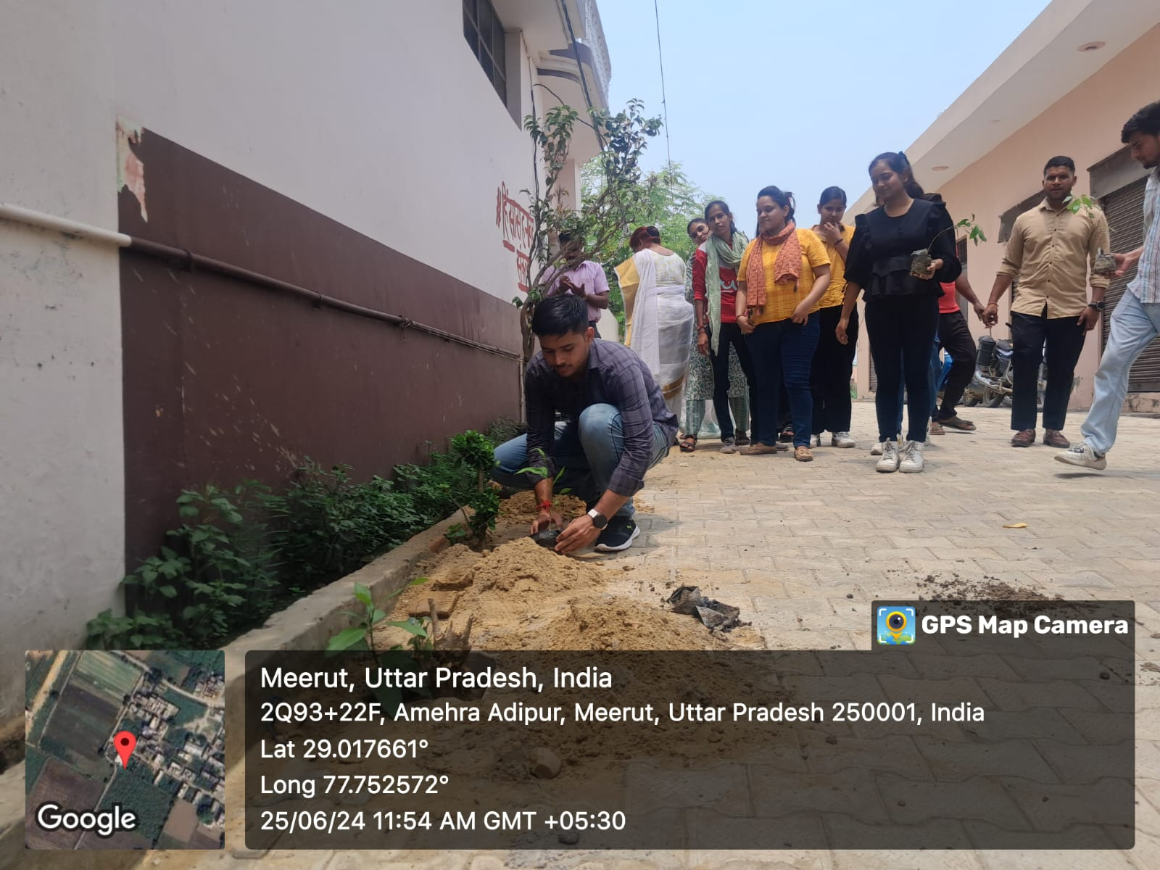

***Date: July 1 , 2024* *Location: Shri Sai Seva Charitable Trust Dada – Dadi Niwas India***

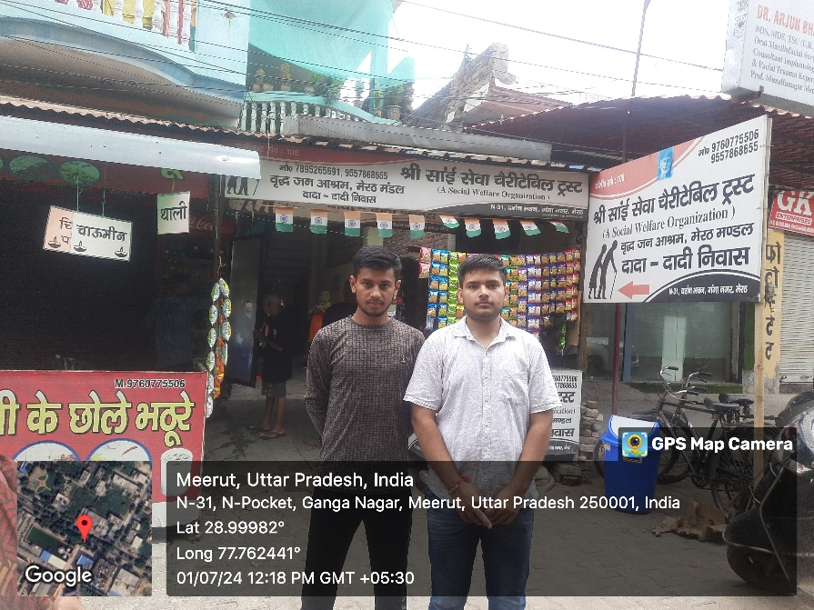

1. **Changing Family Structures**: Traditionally, Indian families thrived on joint bonds—multiple generations under one roof. Elders were revered, their wisdom sought. But modernity brought shifts—nuclear families, urbanization, and migration. The old age home symbolizes this transformation.

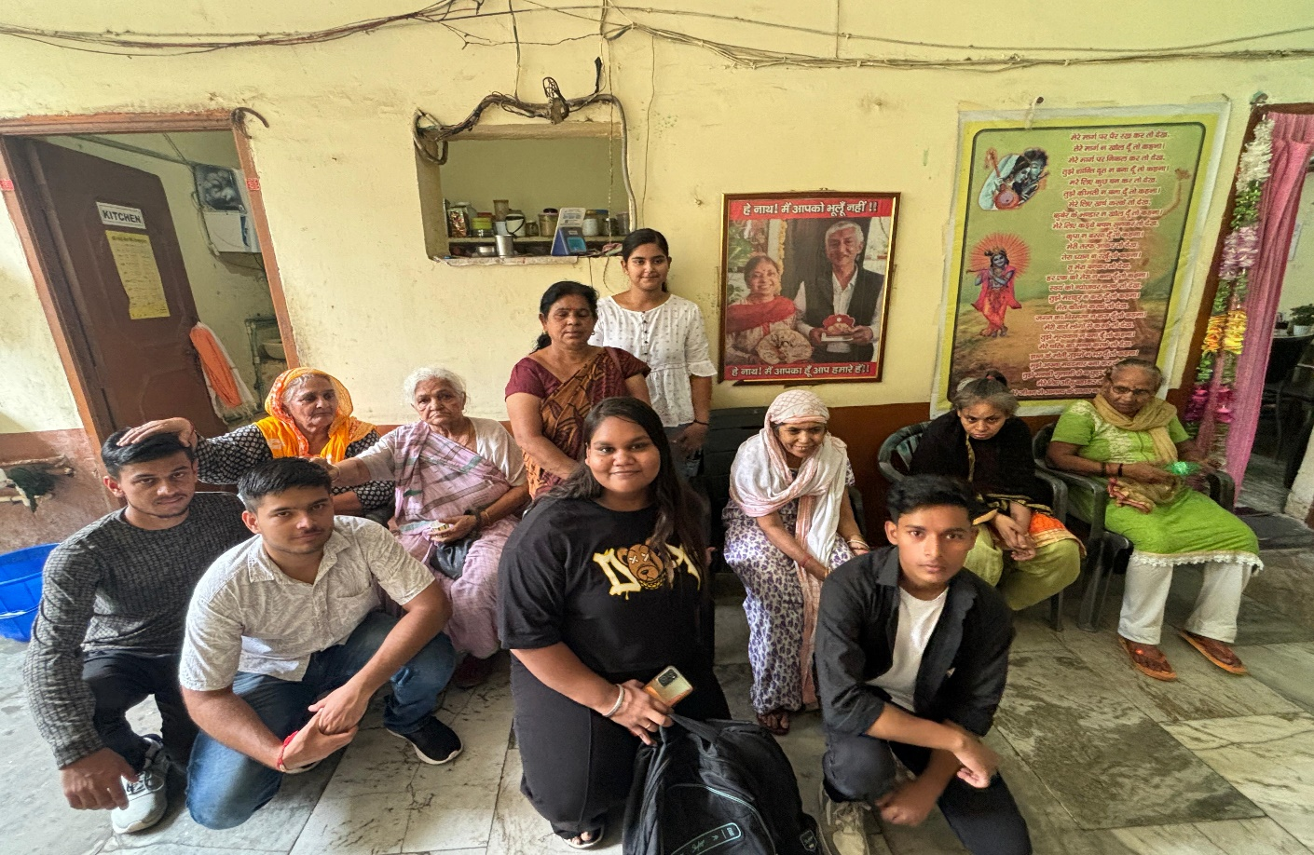

**2. Loneliness and Connection**: The image above hints at solitude. Yet, within these walls,

connections bloom.

Residents share meals, memories, and laughter. The societal health of families lies not only in

blood ties but also in fostering community—bridging gaps across generations.

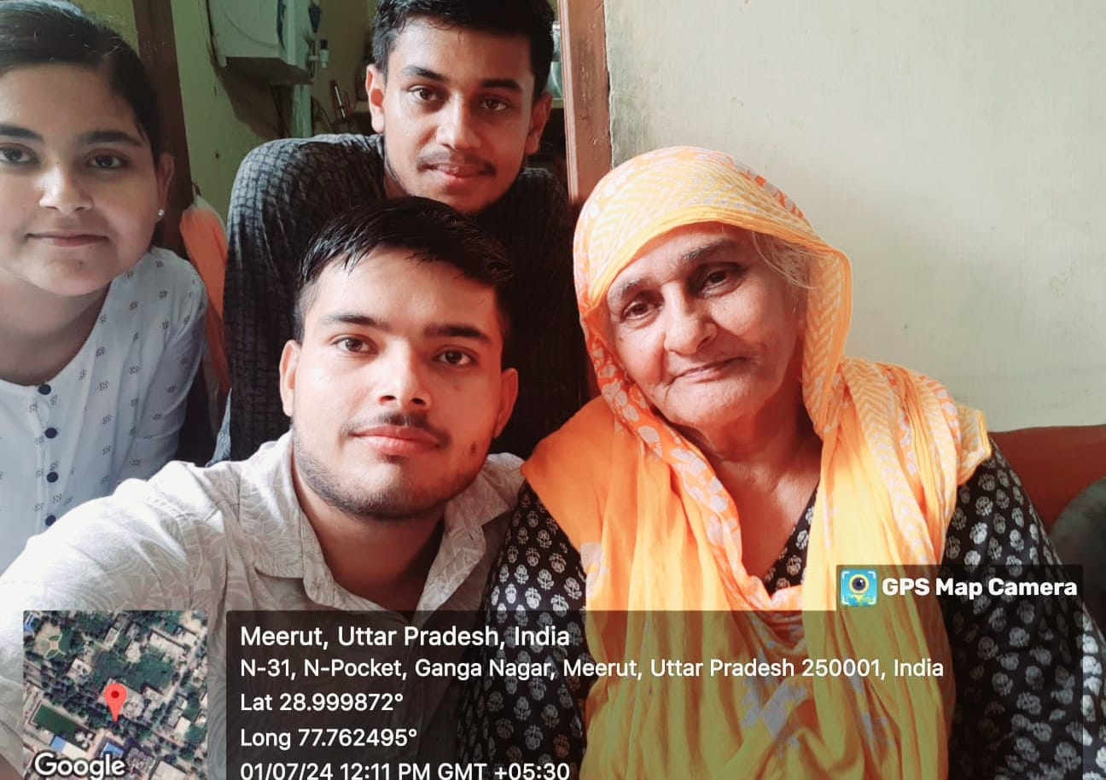

**3.Care and Dignity:** The old age home embodies care. It’s a testament to a society that values its elders. Here, dignity isn’t lost with age; it’s celebrated. Families, too, must learn this art—balancing independence with compassion.

***Kalavati’s Unseen Strength***

Mrs. Kalavati, a dignified woman with silver hair, had arrived at Dada Dadi Ashram in January. Her eyes held stories—the kind that only time could etch. Both her sons, once the pillars of her world, had departed this earthly realm. The void they left behind was vast, yet Kalavati carried on.

One son had been married, and his wife—now a widow—had a daughter. In a twist of fate, Kalavati became not just a mother-in-law but also a grandmother. She embraced her daughter-in-law, weaving love into the fabric of their shared grief. Her husband had passed away seven years ago, leaving her with memories and a heart burdened by sorrow.

Her sister, still living, visited occasionally. Yet, the bond between them was fragile—a delicate thread stretched across time. The sister cared, but practicalities prevailed. Kalavati’s health—sugar levels dancing and heart murmuring—demanded attention. The ashram staff stepped in, ensuring her medication and well-being.

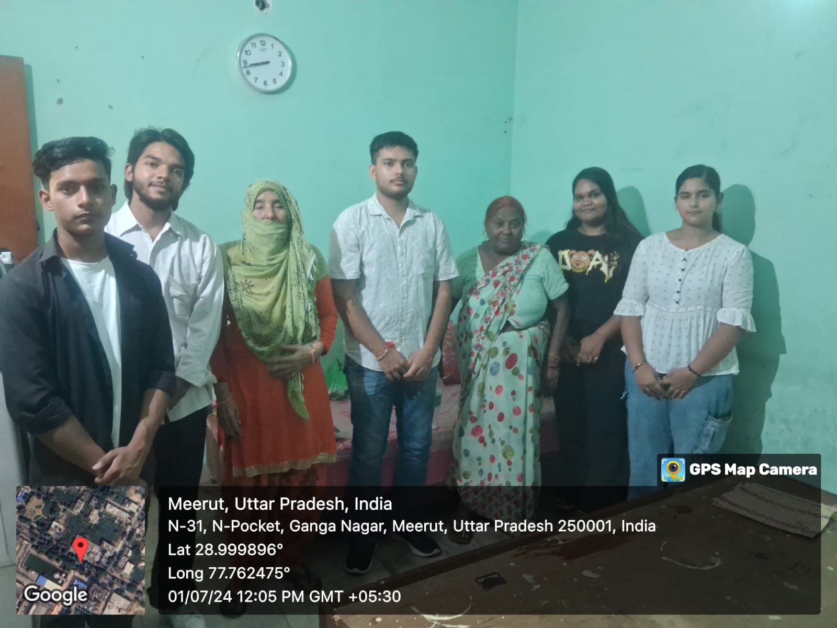

***Kanti’s Silent Struggles***

Kanti, from Multan Nagar, carried her burdens quietly. Family problems—those insidious cracks

that fracture kinship—had led her to Dada Dadi Ashram. Sons and their wives clashed, and Kanti found herself caught in the crossfire. Her eyes held unshed tears, and her hands bore the weight of unspoken words.

Within the ashram’s walls, Kanti discovered solace. Here, she wasn’t just a mother-in-law or a discarded elder. She was part of a collective—a sisterhood of resilience. Together, they swept floors, cooked meals, and tended to the garden.

Their laughter echoed through the courtyard, knitting together the frayed edges of their lives.

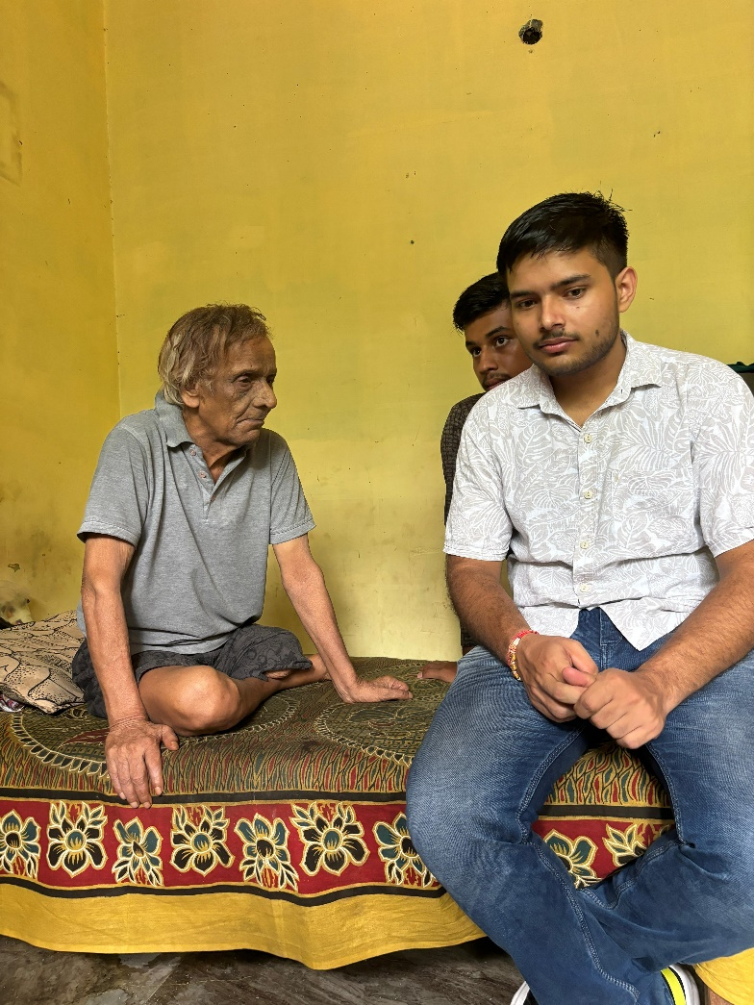

***Vijay Kapoor’s Quiet Corner***

Vijay Kapoor, a man of few words, hailed from Shastri Nagar. His solitude was deliberate—a refuge from a bustling world that had taken much from him. His wife had departed long ago, leaving behind memories of shared sunsets and whispered dreams. Now, within the ashram’s walls, he found solace in the quietude of his room.

Vijay observed the women—their camaraderie, their shared chores. He marveled at their resilience, their ability to mend broken pieces.

* ***Lessons for Families***

1. ***Time Investment: Families must invest time—listening to stories, seeking advice, and learning from elders. Societal health thrives when generations intertwine.***
2. ***Empathy and Patience: Elders face physical limitations and memory lapses. Patience and empathy are vital. Families must adapt, understanding that aging is a shared journey.***
3. ***Inclusion: Old age homes teach us inclusivity. Families, too, should embrace diversity—whether it’s age, abilities, or backgrounds.***

***Date: July 6 , 2024* *Location: Ambedkar Chawk, Nauchandi,Meerut,Uttar Pradesh India***

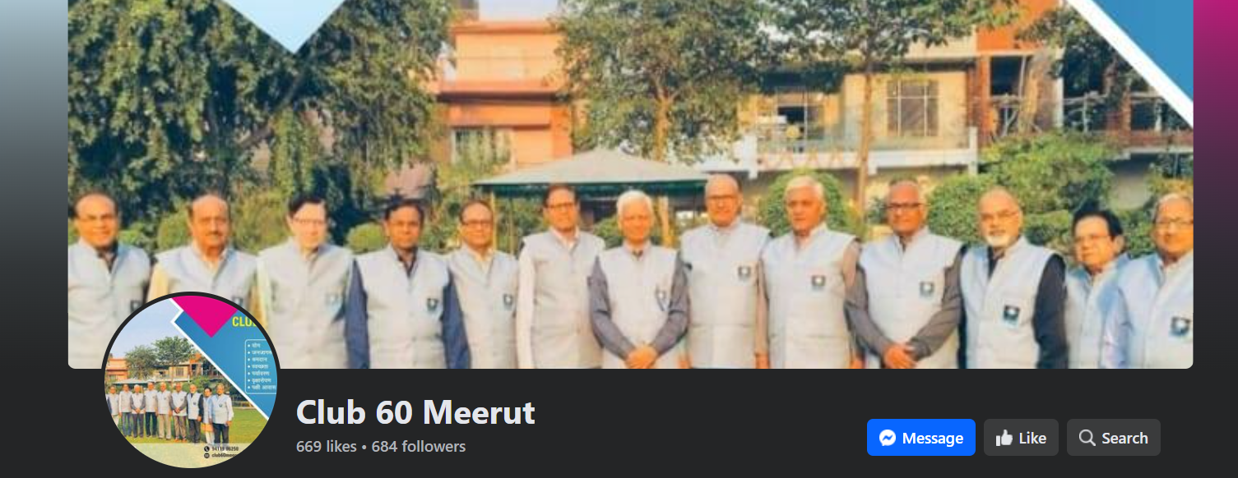

* ***The main aims of our club-60 are yog, awareness of keeping our city clean, Environment , Plantation, Nests for birds, Water Harveting, Vedic Composting and help to poor students***

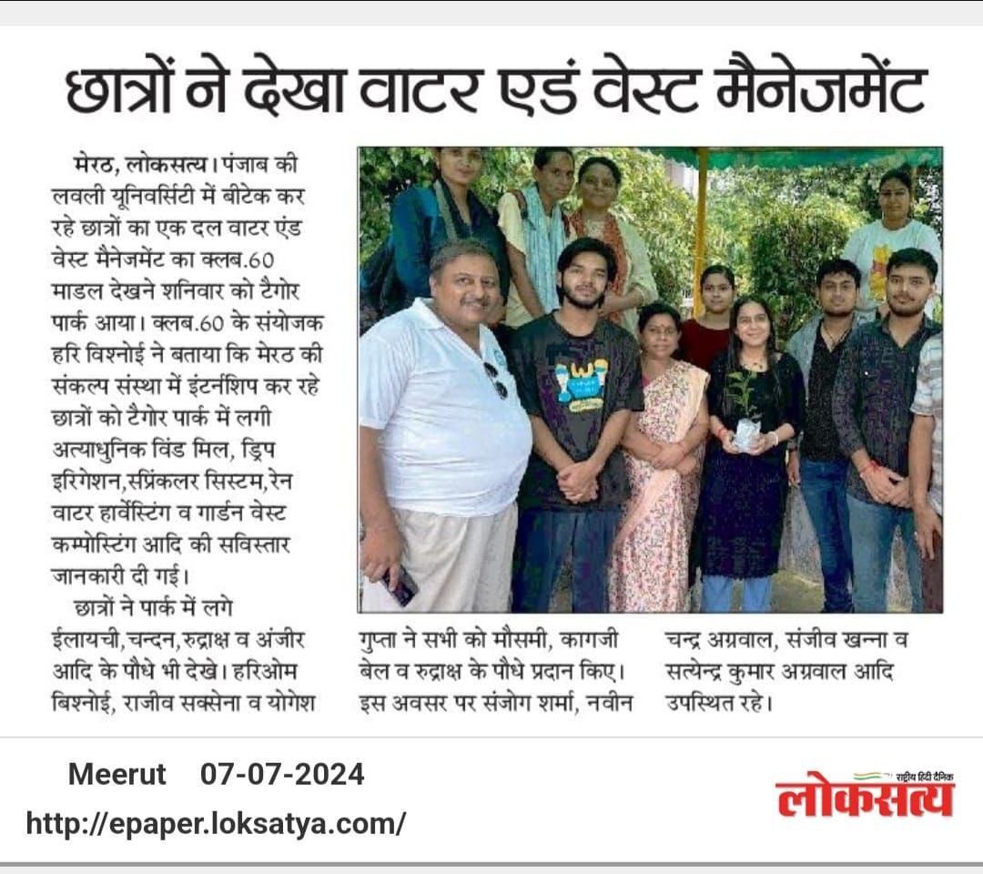

***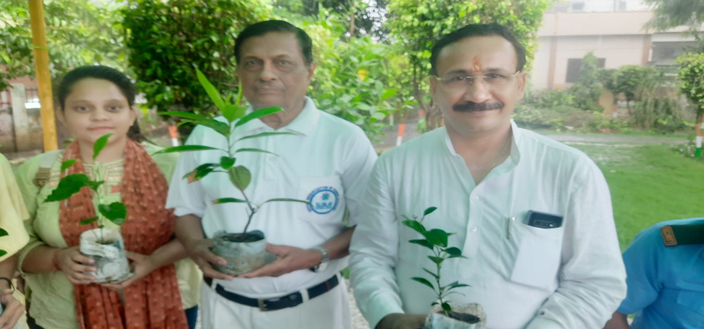****Today I met with Hari Bhishnoi of club60 he spoke of ecosystems—the delicate symphony of soil, leaves, and roots. Each tree, a note; each forest, a grand composition. He urged us to listen—to the rustle of leaves, the hum of bees, and the silent plea of parched earth.*

*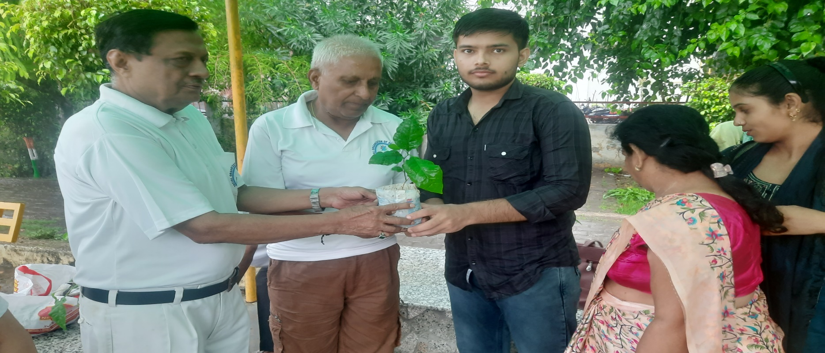Tree as Kin: “A tree is kin,” Hari ji declared. “It shelters, feeds, and heals.” He shared tales of banyans—their ancient wisdom, their embrace of weary travelers. “Plant with intention,” he said, “and watch your family grow.*

*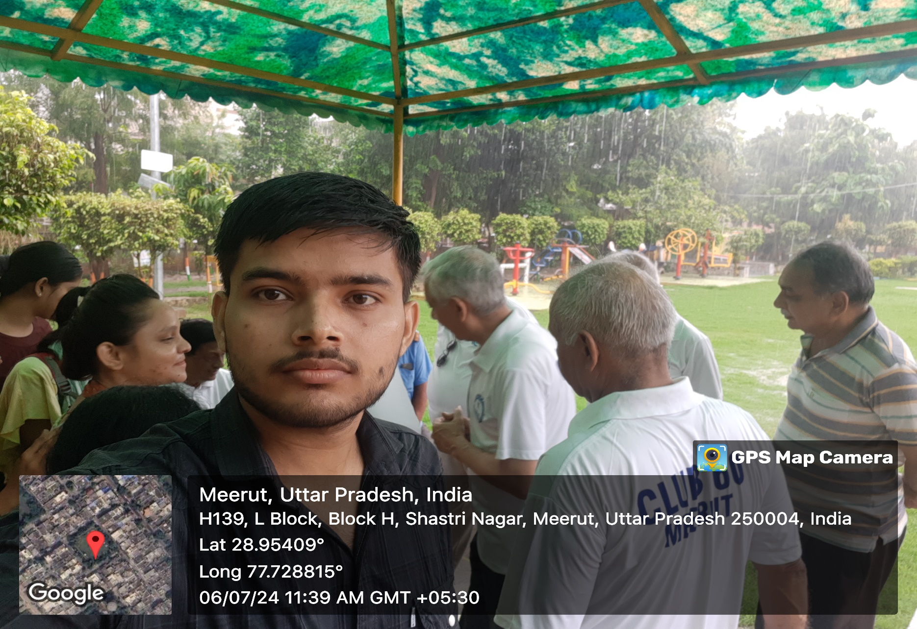 Hari ji demystified photosynthesis—the alchemy where leaves turn sunlight into breath.“Trees exhale life,” he grinned. “Inhale deeply; they gift you oxygen.*

***Current Problem In Society***

* 1. Food Insecurity: Many children from low-income families struggle with consistent access to nutritious meals.
  2. Malnutrition: Inadequate access to a balanced diet can result in malnutrition, impacting physical.
  3. Health Issue: Hunger malnutrition can lead to various health problems, weakened immune systems.
  4. Educational Challenges: Hunger can hinder a child’s ability to focus and learn in school, leading to lower academic performance.
  5. Cycle of Poverty: Poor nutrition and lack of access to education can perpetuate a cycle of poverty.

Now, there two situation arises one of thinking what to do and other is to find the solution of these problem and we and our organization start following second step and start identifying the problem and working in the positive approach.

***Main Target—Objective to be achieved:***

We have categorized our objective in that way so that our goals can be achieve in easy way.

We start with spreading awareness among all class of people so that they at least know about the situation and prevent themselves from taking any step that can be hazardous to their life.

Secondly to fulfil the needs of needy we start donating foods on daily basis with all precaution and safety measure door to door so that everyone can be safe.

We start a campaign of distributing food among people .

At last we will try to encourage the people to feed more hungry people.

# Steps taken to achieve target:

Our first objective is to spread knowledge in order to do so we used all possible technique as:

As we know that now a day people are more adhered to social media, so we try to spread awareness .

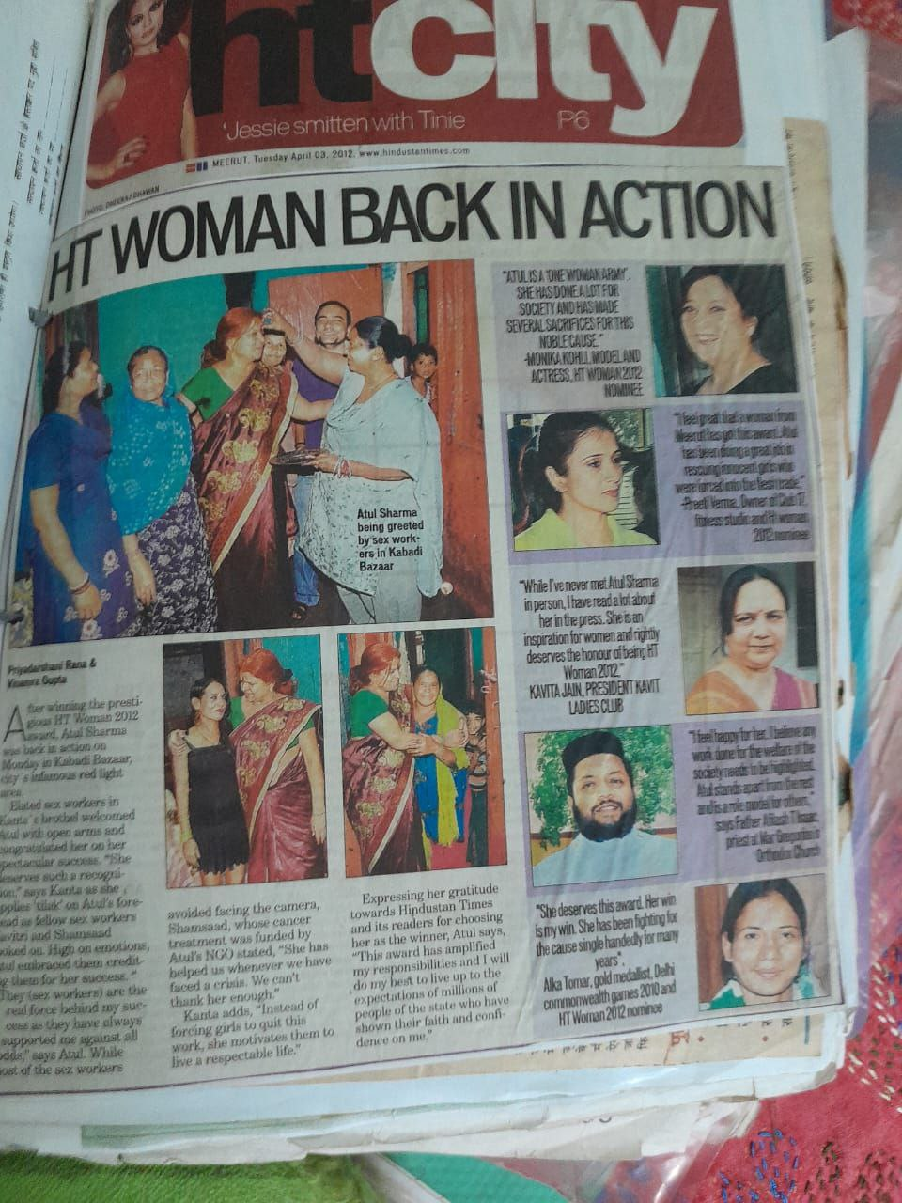

**Atul Sharma Maam creating Headlines and Spreading Awareness**

***Pictures and Previous Work of Atul Maam of Sankalp NGO:***

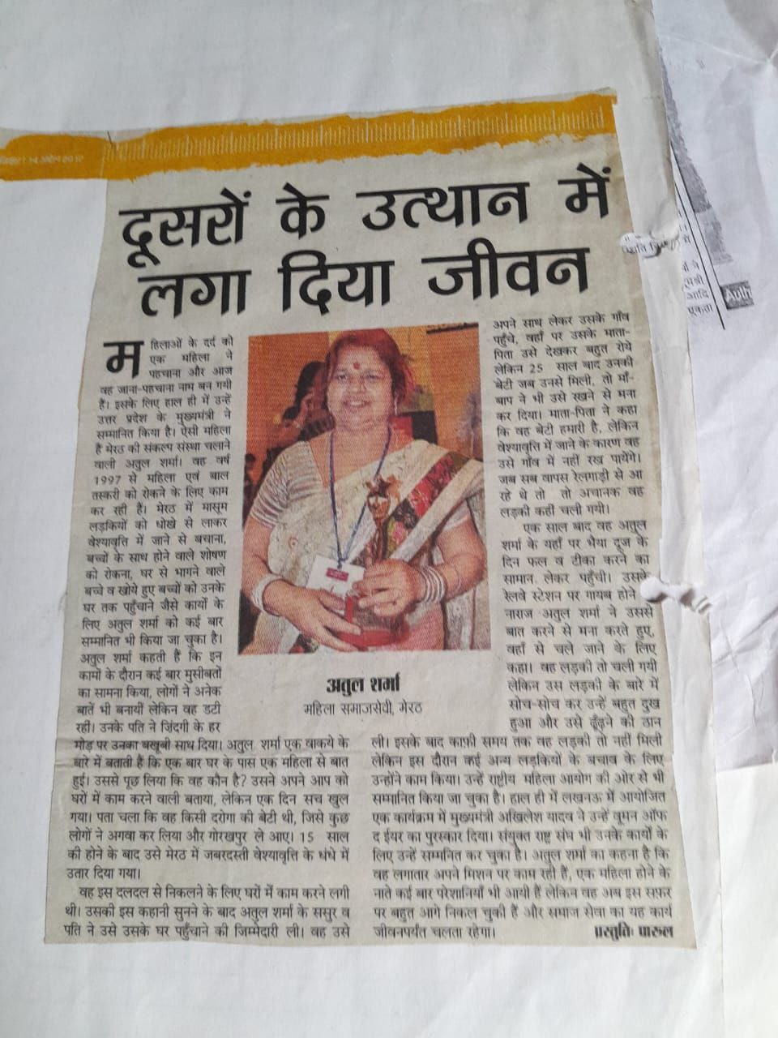

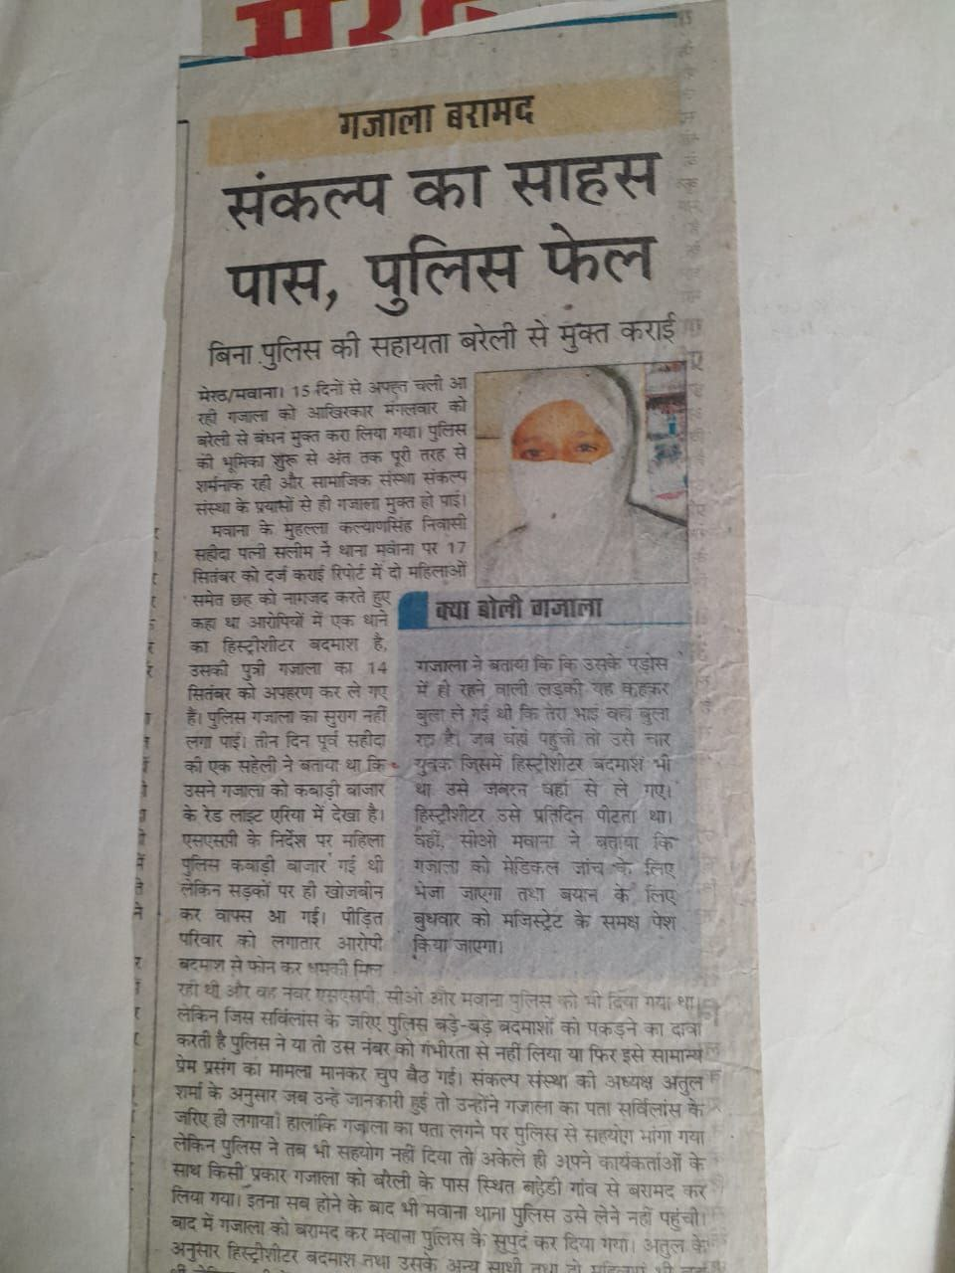

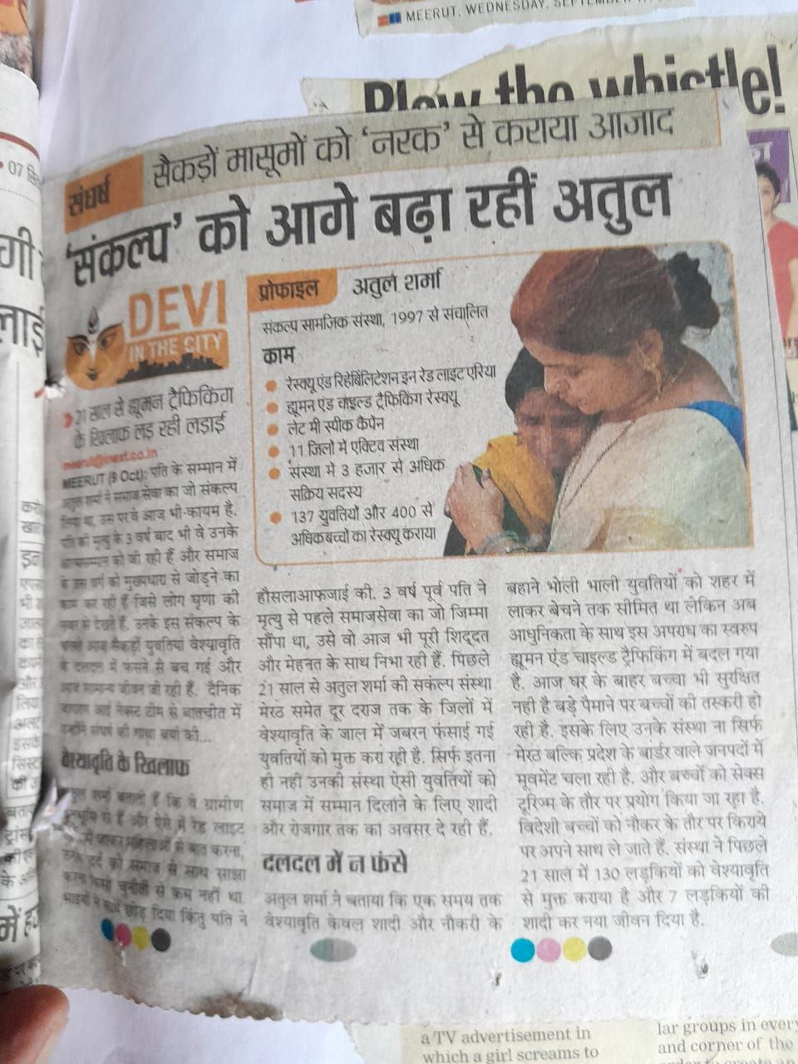

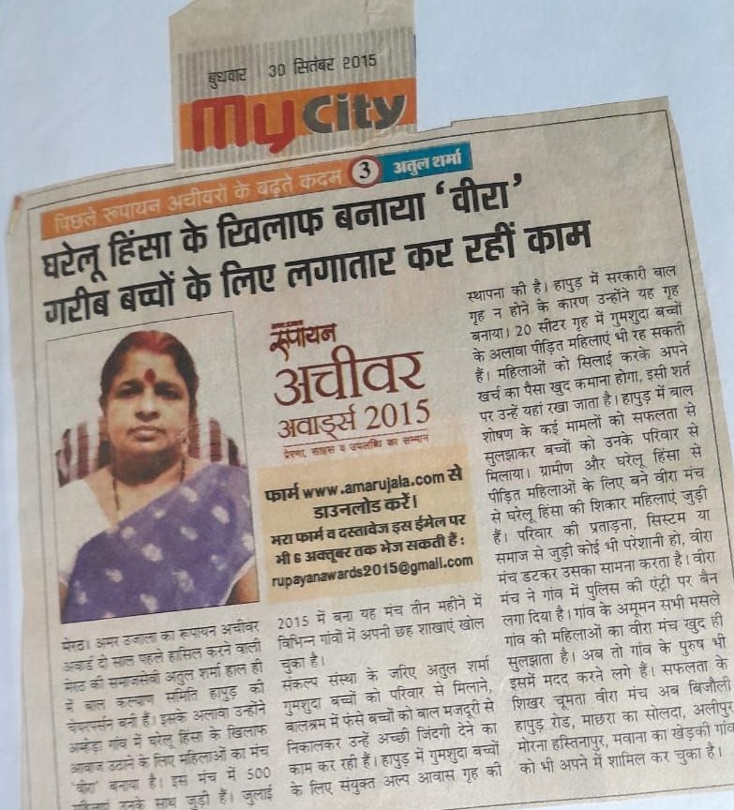

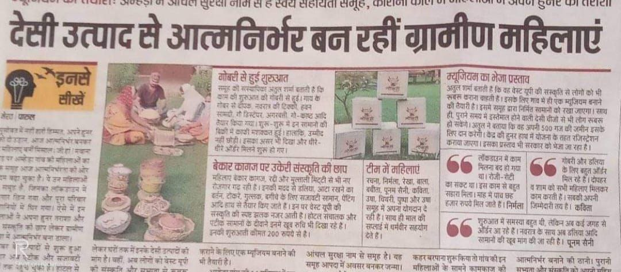

***Sankalp Making Rural women economically independent by helping and watering their Ideas so they can grow***

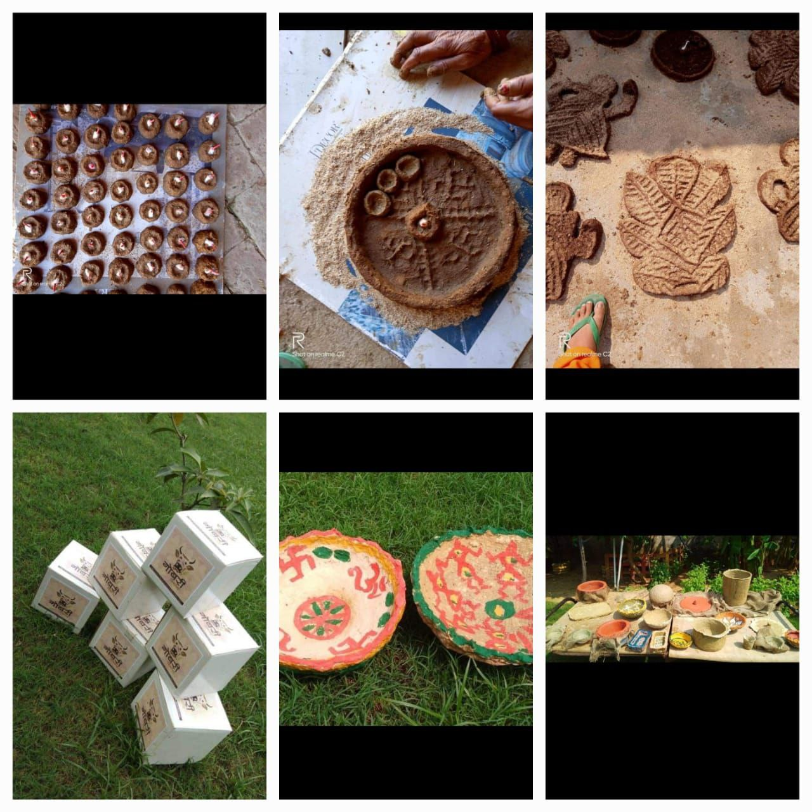

***CHALLENGES***

1. Funding Limitations: Securing sufficient funds to support daily meal distribution, educational workshops, vocational training, and other activities can be a significant challenge.
2. Volunteer Availability: Depending solely on volunteers for every aspect of the plan might lead to variations in commitment and availability, affecting the consistency and quality of activities.
3. Sustainable Impact: Ensuring that the activities have a lasting impact beyond the 30-day period requires careful planning and follow-up.

##### Mitigation Strategies:

1. Diversify Funding Sources: Seek multiple sources of funding, including grants, individual donations, and corporate partnerships, to reduce dependency on a

single channel.

1. Volunteer Engagement: Develop a strong volunteer engagement strategy that includes clear role descriptions, training, and recognition to maintain a committed and motivated team.
2. Long-Term Planning: While executing short-term activities, also develop a roadmap for sustainable programs that can be continued beyond the initial 30- day period.
3. Collaboration: Partner with local organizations, schools, and government agencies to share resources, reduce costs, and expand the reach of the activities

## CONCLUSION

Community development project aimed at creating awareness and providing social security to them by means of **Sankalp NGO** has successfully fostered a sense of unity and collaboration within the organization. Through this initiative, we have not only provided nourishment but also created a platform for meaningful interactions and exchanges between team members. The project's positive impact on employee morale and camaraderie highlights the importance of such endeavours in promoting a vibrant and cohesive work environment. As we move forward, it is evident that the connections forged during this project will continue to contribute to the growth and success of both the individuals involved and the **Sankalp** organization as a whole. Beyond its immediate scope, the project exemplified **Sankalp**'s commitment to social

responsibility and community engagement. Such initiatives not only enhance the organization's reputation but also set a positive example for other corporations. By taking an active role in uplifting the

community, **Sankalp** has demonstrated its dedication to being a responsible corporate citizen. Looking ahead, the connections forged during the project hold the potential for lasting impact. The

relationships cultivated during shared meals are likely to extend into the professional realm, fostering enhanced collaboration and

communication. This newfound synergy can lead to increased productivity, better decision-making, and innovative problem-solving—a priceless asset in today's fast-paced business landscape. In conclusion,

the community development project centred around providing sustenance to the PR professionals of **Sankalp** encapsulates the transformative power of seemingly simple gestures. By creating a platform for interaction, boosting employee morale, and highlighting the significance of PR, this initiative has proven to be a catalyst for

positive change. It stands as a testament to the broad-ranging influence that community-focused initiatives can have on individuals and organizations alike. As **Sankalp** continues to prioritize such endeavours. it is poised to not only nurture its employees.

saa